London SEND Summit Report – March 2024

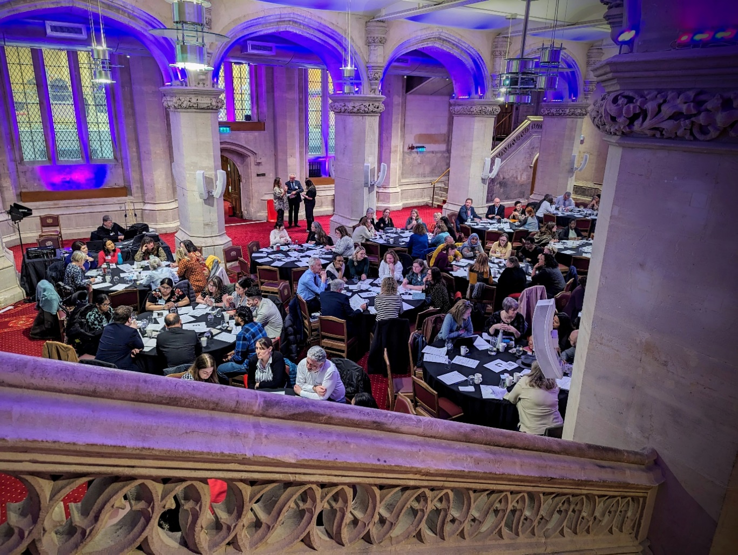
Livery Hall, Guildhall, London, 18th March 2024

Outline of the Day:
The third London SEND Summit convened on 18th March 2024 to hear more from the Department of Education about the implementation of the national SENDAP Improvement Plan, a national programme to develop and test some of the changes the Government wants to make to the system for supporting children and young people with SEND.
Attendees heard from the Department about how the proposed changes will be implemented, alongside other key inputs on improving outcomes for children in London. The Director of London Change Programme Partnership and Director of SEND and Inclusion in Barnet provided an update on progress in London.
The event also provided attendees with the chance to come together and discuss the challenges and opportunities which the Change Programme poses for Local Authorities partners as well as feeding back key issues.
Areas of discission focused on Local Area Inclusion Plans, Advisory tailored lists and new EHCP Templates. Attendees also identified where pan-London support would be beneficial.
Speakers included:
- Elaine Allegretti, DCS Barking and Dagenham, who introduced the summit .
- Russell Davey, Headteacher Oaktree School, who provided a reflection on the changing world of SEND in Education.
- Marc Kidson, REACh – Delivery Partner for the Change Programme Partnership, who provided an overview of the National Change Programme for the SENDAP Plan.
- Karen Flanagan & Victor Roman, Director of SEND and Inclusion (LB Barnet) & Director of Change Programme Partnership for London, who outlined their experience delivering the change programme led by Barnet.
- Faye Sibley - Assistant Director for Children and Young People’s Community Health Services at NHSE, presented on ELSEC (Early Language Support for Every Child).
- Ros Luff, Co-Chair London Region National Network of Parent Carer Forums, who outlined parent carer perspectives on the SENDAP Improvement Plan, and the progress made since the last summit.
- Our Time All Ability Youth Group, Tower Hamlets, presented on the importance of inclusion in practice.
During the table discussions, attendees explored three key reforms proposed via the Change Programme Partnership: Local Area Inclusion Plans, Advisory Tailored Lists, and new EHCP templates.
Regarding Local Area Inclusion Plans, key themes emerged around clarity of purpose and relationship to other plans and the need to strengthen SEND AP partnership boards for effective planning, particularly engagement of ICBs. Also raised were the importance of clear communication channels, defined responsibilities, and integrated health and education collaboration. Additionally, clarity in data management, emphasis on early intervention, and adoption of inclusive practices were recognised as a key part of implementation.
Feedback on Advisory Tailored Lists underscored the urgent need for greater specialist support for children and young people. Effective communication with families, annual reviews for adaptation, clarity on practical aspects, and consideration of staff experience were emphasized. Furthermore, promoting inclusive school environments, nurturing relationships, and mandating participation from academies and free schools were recommended.
The discussion on EHCP templates highlighted the need for wider engagement beyond the Change Programme Partnership local authorities. Issues raised included the need for revisions to category headings and the inclusion of PFA outcomes. Participants highlighted the importance of digitalisation for efficiency and suggested improvements such as increased personalisation of plans and enhanced involvement of social care. The event also highlighted key priorities for pan-London SEND work:
- Unified approach and collaboration.
- Enhancing provision and support.
- Strengthening systems and resources.
Attendees highlighted issues to feed back to DfE –
- Importance of supporting inclusion.
- Clear roles and empowerment of Local Authorities, Education providers and Health partners.
- Increased funding and ringfencing SEND funding.
- Prioritising digitisation.
- Improved communications, particularly to local authorities not in Change Programme Partnerships.

Resources from the Event:
All slides from the SEND Summit can be found here, alongside an audio recording of presentations and discussions.
You can find more information on the Pan-London SEND Programme and other ALDCS Priorities on the LIIA Website, or contact the team directly to sign up to the ALDCS SEND Bulletin or discuss themes from the Summit in greater detail.
LIIA is continuing to develop the London SEND Data Dashboard as part of the SEND programme to support Local Authorities. The dashboard offers valuable tools for London Authorities to facilitate both local and regional monitoring of SEND Services – you can access the dashboard here.

Attendee Feedback:
As seen below, the event received a majority of positive feedback with 67% finding it extremely valuable and 29% finding it valuable.
Attendees reported that presentations added valuable perspectives, and many highlighted the opportunity to hear from a Young People and Parent Carers as particularly important. Attendees also welcomed the opportunity to meet colleagues in person and build relationships across the region and sectors.

Looking towards future summits, attendees offered constructive suggestions including:
- Engage national speakers to bring wider perspectives and inspiration.
- Plan more time for groupwork and feedback, potentially through smaller groups, to bolster peer support and the sharing of best practices.
- Incorporate panel discussions for Q&A sessions and ensure stronger representation of young people's voices throughout the event.

