How to register for the (LIIA) Your Choice Members’ Area
- Go to https://www.liia.london/members-area/your-choice-professional-resources
- In the yellow box, click the link for the registration form (underlined with red below):-
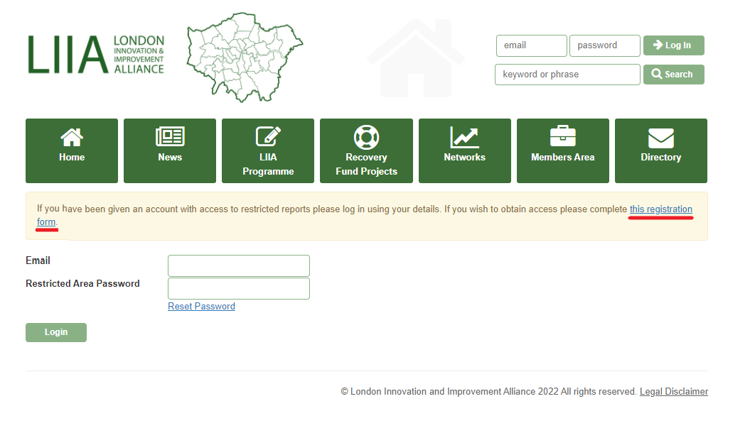
- Complete the registration form

- Once registered, the Your Choice team will receive a notification and will activate your account. We will then confirm that this has been done by email.

