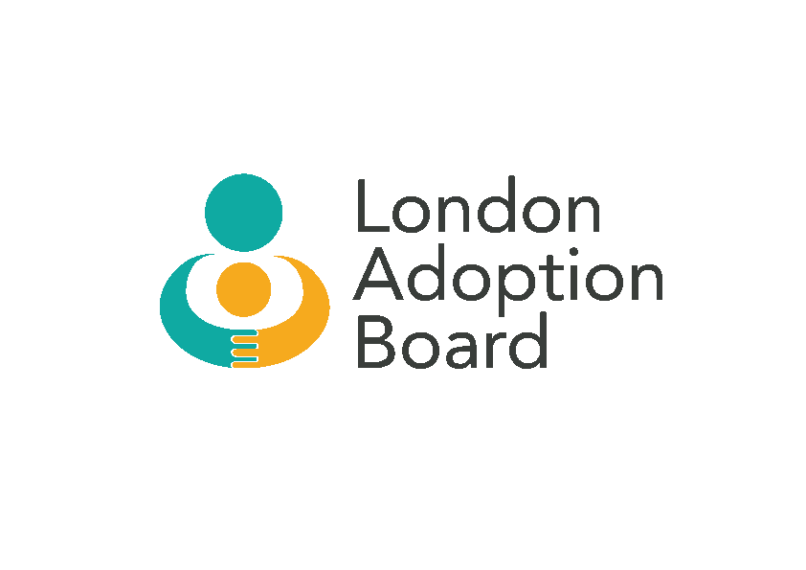

LONDON ADOPTION AND PERMANENCY BOARD
Thursday 5 December 2019
12.30pm – 2.00pm
Chair: Carolyn Fair (CF)

Attendees: Helen Edwards (HE), Alasdair Smith (AS), Susanna Daus (SD), Debbie Gabriel (DG), Lisa Barker (LB), Carol Homden (CH), Kate O’Brien (KO), Klayre Rogers (KR)

Apologies: Annie Hudson (AH), Jan Fishwick (JF), Clive Grimshaw (CG), Karen Gibbings (KG), Sarah Newman (SN), Richard Baldwin (RB), Bryan Edmonds (BE), Sue May (SM)

ITEM |  | ACTION
1. | Apologies  Apologies noted.
2. | Previous Minutes, Matters Arising and Actions 23 October 2019  Accuracy – Minutes agreed as accurate and actions completed.
3. | LAPB Structure, future meetings and feedback from ALDCS  - CF advised that a paper was submitted to ALDCS on 25 November 2019 relating to the performance of the LAPB. The Board is still not working effectively and currently does not secure the necessary buy-in from all key stakeholders and, especially, local authorities. Kevin Yong to circulate the paper which includes which members did/did not submit data to be included in the report.  - The draft ToR was discussed in detail. Going forward, serious consideration needs to be taken in relation to the makeup of the Board, its membership, and who chairs the Panel.  - The ToR also needs to consider the practice and outcomes for children who are placed permanently from local authority care with Special Guardianship Orders, the parallel practice issues and utilisation of the Adoption Support Fund. SD commented that it would be a positive move to include more groups who have large numbers of SGOs.  - CF advised that Alisdair Smith will act as transitional Chair of LAPB for the next twelve months, commencing January 2020. | KY

ITEM |  | ACTION
3. | LAPB Structure, future meetings and feedback from ALDCS (Cont’d)  - Membership – it was agreed that another South London borough be invited to join the membership of the Board. KO advised that Bromley’s Head of Service has advised her that they would be very interested in joining the group as a non-host LA. The group need to identify additional London LA reps for the Board, including non-host LAs.  - CF advised that Andrew Christie emphasized the need for good engagement and dialogue with the judiciary/family courts.  - AS suggested that HoS and AD attendance be discussed at the meeting to be held later this afternoon. AS feels that ADs need to own this meeting. | AS
4. | Regionalisation and Strategy for working together and Sufficiency of Adopters  - DG/SD are continuing to work on Sufficiency Strategy for London. They will be working with KY going forward, who will assist with the development of a dashboard. Not yet in a position to analyse data and recruitment rate. Report will be submitted to Exec Board re marketing work. Once there is a clear plan for marketing we will have a better sense of targets and conversion rates.  - CH reported that National Kinship Week proved to be successful. A national campaign was orchestrated and there followed a high level of enquiries – conversation rates were fairly consistent for London with a good pool of adopters. And a strong, recruitment programme/offer is in place going forward. London adoption gateway has a waiting list but can adjust capacity.  - There have been more adoptions this half year, than the last half year and its rising in South London.  - SD advised they have 30 adopters waiting. 37 families are in assessment. Reviewing how we prepare people’s pathways.  - Diversity – SD advised they were looking at all adopters to assess if they could help a child with a different culture/background – stretching the potential of adopters.  - A discussion took place regarding how to engage with RAAs so that they can work with LAPB to provide peer support to adopters on their journey. Adopters generally go through to post-adoption teams for advice – engagement is very hit and miss. We need to provide stronger referral pathways between Adopters and RAAs. This needs to be addressed urgently.  - DG advised that when Adopt London website goes live it will include information such as where adopters need to look in order to speak to the relevant people about their particular issues.

ITEM |  | ACTION
5. | Adoption Support Blueprint  - All confirmed that they had read through the blueprint and it was absolutely the right thing to be doing. It was an opportune moment for RAAs to map themselves to it and benchmark themselves against it.  - The group agreed that people don't know what they are entitled to and for this information to be included in the blueprint is great. There is very little peer to peer adopters support and is very important. KR to feed back to Andrew Christie as a starting point.  - Feedback comments re blueprint to KO.  - KO suggested a planning consultation with focus group of adopters in spring? | ALL  KR  ALL
6. | ASGLB Update  - Item not discussed.
7. | AOB  - DfE adoption data is to be published today.  - CH requested that the decline in special guardianship numbers is focused on at a later meeting. If the DfE cannot make a case to the Treasury the funds will not be forthcoming.
Date of next Meeting

20 January 2020 – 12.30pm – 2.00pm

