VRU Work Programme

Context

Since 2014 there has been a substantial increase in violence nationally and across London. This was across all types of crime, though media attention focused on youth-related knife crime. In London, the boroughs most affected by knife crime which causes injury are Westminster, Lambeth, and Haringey. Across London, in the last 12 months there have been 1,877 victims of knife crime with injury. During the previous 12 months, to March 2018, there were 2,222. Looking at violence more broadly, we can see that Westminster, Croydon, and Newham are most affected boroughs.

London Violence against the Person
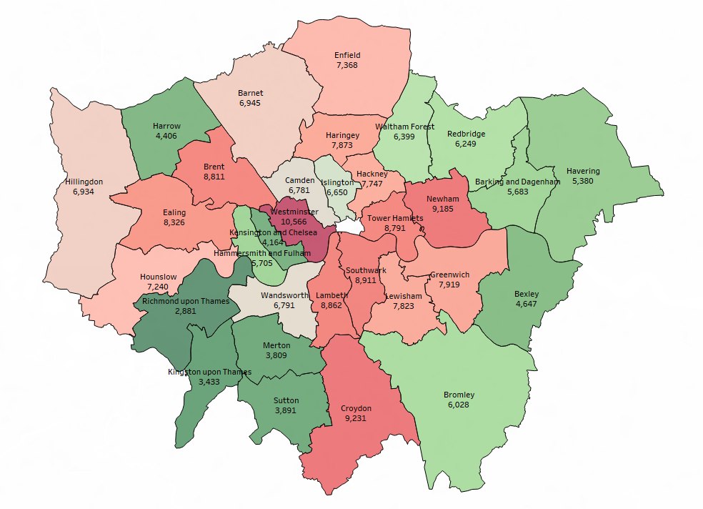

This is a trend repeated in cities across the UK, with violence against the person and knife crime increasing significantly. In the 12 months to September 2018, the volume of Violence Against the Person offences increased by 20% compared to the previous year nationally. Offending increased by 6% in the MPS during this period. Additionally, Knife Crime offences increased by 8% both nationally and the MPS.

The combination of the increased number of public attacks and homicides combined with the young age of many of the perpetrators and victims provoked national concern.

The statistics also revealed a huge disproportionality in the ethnicity of both victims and perpetrators alongside glaring disproportionality in the criminal justice system. Black Londoners are more likely to say they feel personally affected by crime, 44% to 32% of non-black Londoners, and this is supported by evidence on knife crime, where 26% of victims and 46% perpetrators are Black. The disproportionality is even more shocking when it comes to homicide. When considering the rate of recorded homicides in 2018, there were 4.8 homicides per 100,000 Black Londoners compared to 0.97 per 100,000 White Londoners.

The picture of inequality exposed aligns with the areas of multiple deprivation in London; at a ward level, the areas most affected by violence are those with the most significant deprivation. The recent report published by ONS into homicides to end of March 2018 indicates that there are likely to be important socio-economic factors in homicides that cannot be examined using homicide data. The report cites evidence from Leyland and Dundas (2009), for example, which investigated homicides in Scotland between 1980 and 2005, and concluded that “contextual influences of the neighbourhood of residence might be more important than individual characteristics in determining the victims of assault”. From mapping the homicides in London over the last three years to the electoral ward level, we can identify that over half of all recorded events (52%) occurred in just 12% of London Electoral wards. Furthermore, 41% of those wards were within the 20% most vulnerable wards in London.

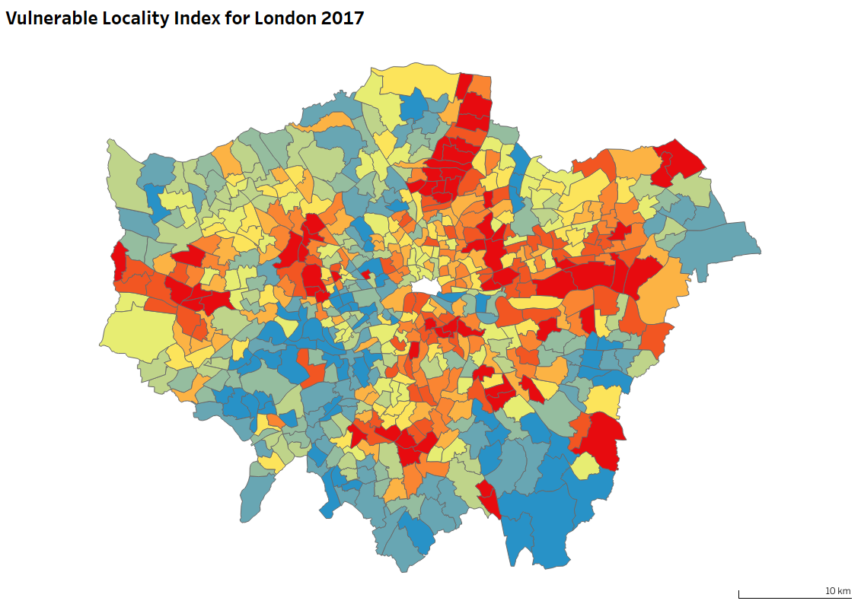

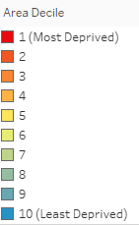

This inequality has been further exacerbated by nearly a decade of austerity: London police numbers have fallen below 30,000 for the first time since the early 1980’s, and front-line services have been hit hard by cuts to local government and education.

Despite this pronounced inequality, the intense media interest provoked a substantial increase in London citizens’ fear of violent crime, which did not correlate with the neighbourhoods and communities they lived in.

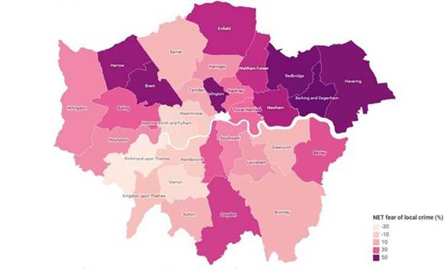

To tackle this increasingly worrying and fatal crime, the Mayor’s team developed a knife crime strategy and held a successful conference in June 2018. Working with the 32 London boroughs and alongside the Met Police, each local authority produced detailed knife crime plans from which it was possible to discern best practice. A year on, overall a significant majority of the CSP Knife Crime and Serious Violence Action Plans are of a good standard, with comprehensive actions and activity in place to develop them further. It is intended that CSP’s will use April-June to conduct a review of their plans and then submit a refresh. This process will include opportunities for briefing sessions with the VRU and MPS as well as senior CSP practitioners to highlight and share areas of good practice. The refresh process will be an opportunity to further expand on innovative work in education, children’s social care and health.

The Mayor and his team also embarked on an engagement programme, to enhance City Hall’s understanding of the community’s experience of serious youth violence and working locally to tackle it. This included a summit at City Hall in April, information sessions for VCS organisations delivering applying to the Young Londoner’s Fund, and a series of roundtable discussions across the boroughs led by the Deputy Mayor for Social Integration, Social Mobility and Community Engagement. Community feedback throughout this process was crucial for developing our understanding of some of the key issues facing communities including the lack of trust in institutions and a desire for asset based, locally informed support and delivery.

Since the start of his administration the Mayor has prioritised tackling violence against women and girls (VAWG) with the publication of an integrated VAWG strategy and record levels of investment. The map below shows combined domestic abuse and sexual offences in London in the year to March 2019.

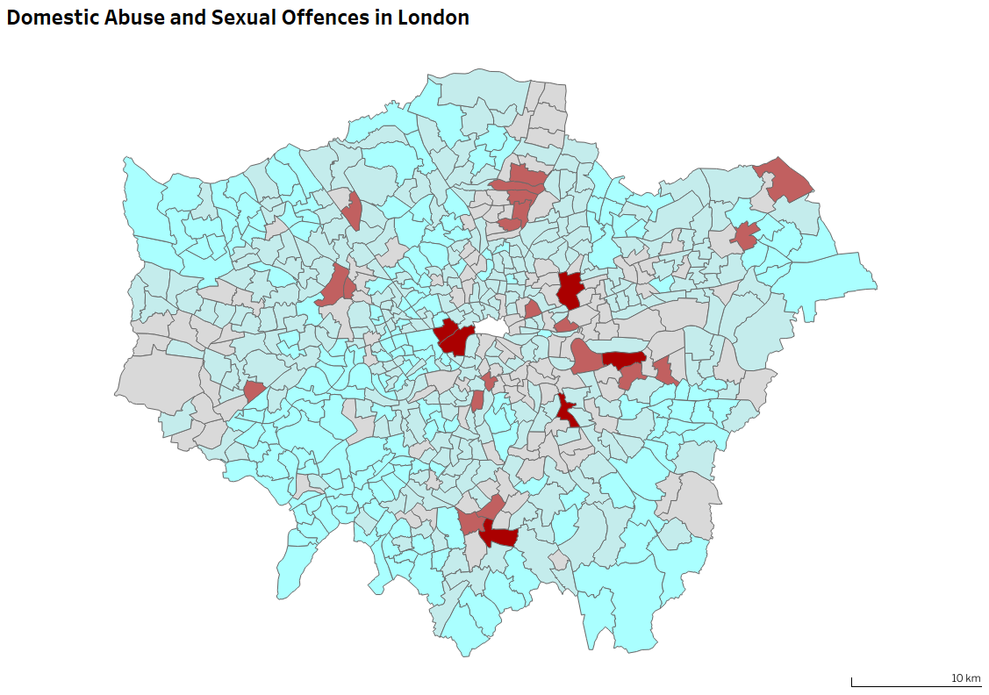

Most recently, the Mayor made additional £15 million of investment has been agreed which MOPAC working with the voluntary sector is commissioning for support services. Tackling violence against women and girls will be an element of the VRU’s long term work programme.

Nationally and internationally, there were strong examples of where a long-term approach towards tackling violence, based on public health principles, had brought large reductions in serious violence. Learning from Glasgow, New York, Chicago and other cities, the Mayor’s office decided to set up a Violence Reduction Unit.

This was the first example of its kind in England and Wales bringing together representatives from the voluntary, community and youth groups, and specialists in health, education, police, probation and local government. Importantly, it was set up to deal with all aspects of violent crime.

Approach and Principles

A contextual violence reduction approach

A public health approach means no more looking at violence as an isolated incident. It doesn’t mean excusing criminality but it does mean to genuinely change behaviour we need to look at the context and influences that impact on individuals at significant points in their life; acknowledging that no individual operates in a vacuum but is both part of and influenced by a huge range of other contexts. Then, taking learning from research, data and evidence, we will develop a full programme of work.

The VRU will adopt this contextual safeguarding approach which focuses on:

  - Children and Young People – reducing Adverse Childhood Experiences and building resilience
  - Families and Home – Support & enable them to nurture and protect young people
  - Peers and Friends - Support young people to be the best they can individually and together
  - Community and Neighbourhoods - Enable and Empower communities to lead from within to build sustainable futures
  - Institutions & systems - Institutions providing responsible leadership; London partners having mutual accountability to invest in what works
  - City and Place - Building a London that is safe, united and inclusive
  - National and International context - learn from and share with the global community to build on what works and improve outcomes for all
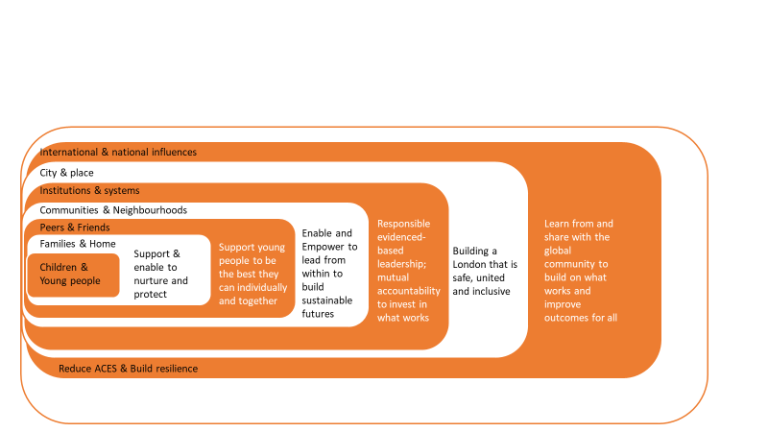

This approach translates into the child’s journey through life with each young person’s interaction with different levels of society expanding as they grow older. As they move from the home into the community, there are a broader range of influences and experiences which can impact on them. For most children growing up in London, these experiences reflect the fantastic range of culture, diversity and opportunity available. But for some, there are a more challenging or problematic experiences.

The term adverse childhood experiences (ACEs) is used to describe experiences that directly hurt a child (e.g. physical, sexual or emotional abuse) or affect them through the environment in which they live. This includes growing up in a household where: domestic violence, parental separation, mental illness, alcohol abuse, or drug abuse is present, or where someone has been incarcerated, as well as being excluded from school or suffering other social exclusion. Suffering four or more of these experiences in childhood has been shown to increase the chance of high-risk drinking in adulthood by four times, being a smoker by six times and being involved in violence in the last year by around 14 times.

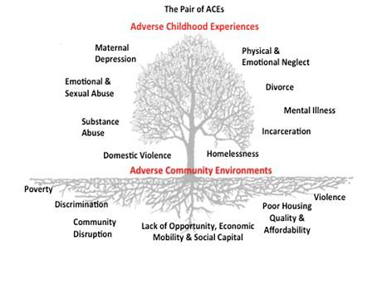
Building the evidence base

At the first meeting of the Partnership Reference Group, the Mayor commissioned four key pieces of work to help build the evidence base for the VRU and track its impact. These were;

- A Strategic Needs Assessment
This will help inform the VRU priorities by setting out the strategic needs and requirements across London that will help to deal with violence.

- A Review of Homicides and Serious Case Reviews
A thematic review of homicides across London, to establish key causation factors, common patterns and to help bring forward recommendations for the VRU and partners to consider in developing a longer-term strategy.

1 and 2 are being delivered through a partnership of Social Care Institute for Excellence, the University of Bedfordshire, and the Behavioural Insights Team. They will be working alongside MOPAC Evidence & Insight to produce published reports in July 2019.

- A Performance Framework

This will be produced following details of the VRU work programme, to track activity against the three strategic objectives.

- A Delivery Model

This has been refined following the practitioner workshops, community involvement planning meetings, input from Chief Executives of London Councils, and feedback from the voluntary and community sector. The model no longer focuses on a six hub, sub-regional approach but instead on a more hyper-local, place-based approach. This allows for a deeper understanding of, and investment in, particular areas of London which are either experiencing significant increases in violence (in which case we want to invest in community-led, innovative solutions) or decreases in violence (in which case we want to learn from the activity and share that with other areas). This means that in the first instance the VRU’s delivery will focus on priority areas of London and not cover all of London.

A sustainable, long-term approach

We recognise that the aim of a public health approach is to include both short-term and long-term solutions. To create system change, we need to test our approaches and learn from them. The activity outlined in this report will be initiated over the next 12 months, with delivery over the next 18 months at which point the impact will be reviewed.

Commissioning framework

The Mayor has been very clear that the vast majority of the funding for the VRU is to be spent locally and in a rapid, transparent and accountable way.

Through a series of meetings with community practitioners, sessions with the Voluntary Community Sector, and discussions with London local authority Chief Executives, the VRU is proposing that a Commissioning Framework should be drawn up with regard to:

- Clear and transparent criteria for funding which in the first phase will focus on where the problem is most intense and where community activity is strongest

- That there is a proven and strong connection between VCS and local authority in the geographical areas

- That there would be a clear correlation between the interventions developed through evidence and encouraged at a regional level and those working at a local level

- That the commissioning will be distributed at an appropriate level be that ward, borough or multi borough approach

We are working with the London Funders to incorporate their principles of good practice commissioning into a future commissioning framework.

Objectives and work programme

Our work programme will be shaped around intervention and activity that reflects and is relevant to a young person’s journey through life. We have started with the individual, families and home, broadening to include peers and friends, to playing a part within communities and neighbourhoods, interacting with more institutions and systems, and having a greater understanding of the city and place, and finally addressing national and international influences.

Our work programme encompasses the following core objectives:

- Supporting individuals to be more resilient
- Supporting stronger families
- Keeping schools safe, keeping young people in school and improving alternatives
- Giving young people every chance to succeed
- Keeping young people safe in public areas and encourage greater activity during holidays
- Changing the message around violence

Objective 1 - Supporting individuals to be more resilient
Reduce Adverse Childhood Experiences and build resilience

Why

We know that confidence in public services is one of the biggest deterrents to people using them, in particular young people. The Care Quality Commission identified a range of barriers preventing young people from accessing mental health support. Only 50% of young people have a ‘good opinion’ of the Met police, and only 44% of young victims reported their crime to the police. Through the practitioner workshops, frontline experts told us that parents sometimes avoid seeking help from social services for fear of being drawn into ‘the system’, and being blamed.

An increased understanding of the interconnectedness of the causes of violence and the complexity of social issues (violence, mental health, drug and alcohol abuse, marginalisation, socio-economic inequalities to name a few) should provide the drive for services to collaborate.

104 London youth clubs and council youth projects have closed their doors since 2011, with a reduction in investment of £145m. Those that remain are embedded in communities and are trusted by them in ways that statutory services are not. Nine in ten UK households have used a charity at some point, and around three quarters (74%) have used a charity service in the last 12 months. In a survey of 2,901 people, responses showed that charities are best placed and most trusted to speak on behalf of the disadvantaged – 67% felt that charities were best placed to speak on behalf of disadvantaged people and 56% said they most trusted charities to do this.

Objective 2 - Supporting stronger families
Supporting parents and carers to nurture and protect

Why

A recent Vulnerable Adolescent Review published by Croydon found that 42% of vulnerable children had grown up in homes where domestic abuse was an issue.

The 2017 report on the Joint Targeted Area Inspections (JTAIs) of children and Domestic Abuse (DA) recommends paying more attention to the emotional, psychological and practical needs of children, moving away from a ‘failure to protect’ discourse with victims (as a result of which children and their non-abusive parent can become alienated from the services which aim to support them) and having greater focus on the attitudes and behaviour of perpetrators.

- To develop resilient families who can spot vulnerabilities in children and know where to access support
- To ensure that adults who are experiencing domestic abuse are supported with parenting and not further penalised for being victims

Objective 3 – Young people leading change
Support young people to be the best they can individually and together

Why

In all of the consultation with communities and young people undertaken thus far, the need to have young people shaping and designing the response to violence in London has been highlighted time and time again. For the VRU to develop a unique approach to violence affecting young people, we recognise that this needs to be led by young people and we will provide the resources, support, and infrastructure to enable this to happen.

- To establish a strand of work, led entirely by young people, which develops a peer-to-peer response to violence

Objective 4 - Enabling local communities to be strong, safe and resilient Enabling and empowering communities to lead from within to build sustainable futures

Why

Strong communities are at the heart of our strategy to tackle violence in both the short and long term. Through working with and listening to the VCS, front-line practitioners and the police we are aware that finding, supporting and promoting best practice is one of the key asks of the VRU.

- To identify the key barriers to community trust and work with the police and other public services to foster greater openness and transparency to inspire greater confidence

- To support through local delivery clearly defined programmes of best VCS and community activity through funding, evaluation of projects and promotion of best practice in those areas most affected by violence or delivering promising practice to learn from

- To ensure that there is a comprehensive package of support for communities to access following a violent incident

Objective 5 - Keeping schools safe, keeping young people in school and improving alternatives
Institutions providing responsible leadership; London partners having mutual accountability to invest in what works

Why

Schools have a clear duty to keep students safe, and there is substantial evidence that schools are one of the safest places for young people. Croydon’s Vulnerable Adolescent Review found that exclusion from school was a common factor in the most vulnerable young people in the borough. All of those excluded from primary school went on to be involved in the criminal justice system. Exclusion from school is one of several adverse childhood experiences which can increase the likelihood of being involved in or affected by violence in later life.
The recent Ofsted report outlined that schools were sometimes wary of directly addressing the issue of knife crime, in case they were seen to be less safe than other schools in the area. By creating a best practice standard for schools to adopt, they can demonstrate that they are prioritising safety and wellbeing of students.

- Developing safer schools to embed physical safety and encourage openness, emotional resilience and well-being including mental health provision

- Create standards through a demonstrable programme of activities, drawing on current best practice in both primary and secondary schools

- To reduce the number of young people excluded and missing from mainstream education at both primary and secondary levels

- To support young people at difficult points in their school journey, particularly those with special educational needs, and to support successful primary and secondary transition.

Objective 6 – Giving young people every chance to succeed
Institutions providing responsible leadership; London partners having mutual accountability to invest in what works

Why
In London, reoffending rates for adults have remained steady for a decade at around 27%. Adults who served sentences of less than 12 months reoffended at a rate of 64.6%, compared to 29.9% for those who served sentences of 12 months or more. For those who are in prison, we need to create safe spaces for them to be rehabilitated. Where they are in the community, we need to ensure joined up service provision, targeted at those who need the most support to turn their lives around.
From the work on ACEs, we know that young people who are involved in offending and violence have often experienced harm and are themselves victims. The ‘victim-offender overlap’ is a widely acknowledged and has become one of the most empirically supported and established findings in the field of criminology.

- To support initiatives across the criminal justice system to reduce violence and provide support to offenders

- To recognise the disproportionate number of young black men in the criminal justice system, and target supportive interventions to get them out

Objective 7 – Keeping young people safe in public areas and encourage greater activity during holidays
Building a London that is safe, united and inclusive

Why

The statistics around knife crime and domestic abuse are most concentrated in school holiday periods. Young people are most often at risk during travel home from school. We know from scrutinising data maps that certain transport hubs in London are much more likely to be the scene of violence.

- To increase and promote activity for young people during the times of 4-7pm during the weekdays.

- To ensure that there is a full and promoted programme of activity for young people and families during the school holidays

- To work with young people how we can focus efforts on making the most dangerous transport hubs safer.

Objective 8 - Changing the message around violence
Tackling and changing international and national influences, building on what works and improve outcomes for all

Why

The way in which issues are presented by the media, politicians and others, shapes our views, and as a result, can shape our behaviour.

Research from Scotland indicates that images of knives and weapons can induce fear in young people, leading to a greater likelihood of feeling that they need to protect themselves by carrying a weapon themselves. Surveys of young people in London support this, with young people stating that seeing a media campaign with knife images would be more likely to make them feel scared, and be worried about knife crime. Catch22 outlined a range of ways in which media and social media influence young people and can increase the likelihood of violence.

The Runnymede Trust found that four out of every five people (78%) thought that the way that the media portrays ethnic minorities promotes racism. This concern was not just expressed by respondents who were from minority ethnic backgrounds; over two-thirds (76%) of White British respondents thought that the media’s representation of minority ethnic groups fuelled racism. Community groups report the impact that the perception of black men as solely the victims and perpetrators of crime can have on their own perceptions and aspirations, and that of others.

MOPAC’s Public Attitudes Survey found that 67% of Londoners living in vulnerable areas are concerned about drugs. In Drugs Prices and Systemic Violence: An Empirical Study (2008), Sarrica maps drug prices against criminal activity; there is strong evidence that the price of heroin drives greater violence. On one hand, some Londoners are concerned about drug use and sale in their areas; on the other, drug use can be seen as a ‘victimless’ crime.

- Develop a clear, simple and jargon free language around violence that can be a positive message of hope to both reassure and encourage London citizens

- To develop a movement against violence that draws on ambassadors to promote positive messages and activities for London citizens to get involved to support local communities

- To discourage the imagery of knives and other shocking newspaper and social media headlines that spread fear rather than understanding about the causes of violence

- To confront head-on the much promoted but inaccurate idea that youth violence is black on black violence

- To make sure that domestic violence is a key part of the narrative and not eclipsed by national focus on street/knife crime

- To understand the relationship between drug use, drug sales, organised criminality, and violence

Governance & partnerships

The Partnership Reference Group has been invaluable in providing strategic direction, support and challenge to the Violence Reduction Unit. While the PRG was originally envisaged as a temporary working group, the Community Involvement proposal – see paper – recommends its continuation into a quarterly meeting as well as an expansion of its membership, redefined terms of reference and a different way of working.

Throughout the development of the VRU community engagement has been essential. Community involvement will be integral to the VRU’s future success. The PRG Governance paper outlines proposals for how this will be taken forward, as well as the approach for involving young people in both design and delivery.

Building on the extremely successful health roundtable chaired by Dr Tom Coffey and including senior representatives of the health sector, the VRU intends to hold similar roundtables for other key public sector partners.

As the work programme develops it is assumed that there may be a need to establish time-limited task and finish groups to focus on a strand of work; and that the GLA partnerships will seek out the VRU as an expert partner to be consulted on commissioning and policies that will impact on the work to tackle violence.

Finance and Resources

The Violence Reduction Unit has a budget of £6.8 million for 2019-2020. The operating cost of the VRU to allow a small directly funded directorate operating from City Hall, with the vast amount of the budget being spent on direct services across London.

In addition, funds from across MOPAC and the GLA are supporting VRU activities, notably in the case of MOPAC the £1m safer schools funding. and the GLA’s £45 million Young Londoners Fund which is supporting local networks tackling youth violence alongside projects increasing opportunities and activities for young people.

Going forward we intend to make sure there is an even greater alignment of strategic funding across City Hall, and beyond with London partners. The VRU is working closely with the London Funders about both increasing the amount of funding and the alignment of funders to support the work of the Violence Reduction Unit; and has started conversations with the Mayor’s Fund.

In the 12 months to March’18
according to the Vulnerable Localities Index.
Review of children and young people’s mental health services, CQC, 2017
MOPAC Youth Voice Survey, 2018
Law enforcement and public health: recognition and enhancement of joined up solutions, The Lancet, January 19, 2019
Charity Street, Charities Aid Foundation (2018)
Ibid
Safeguarding children and young people in education from knife crime, Ofsted, 2019
Oxford Bibliographies; Some of these efforts include chapters/entries by criminologists such as Berg and Felson 2016, Jennings 2016, and Schreck and Stewart 2011 which summarize the recurring themes on the victim-offender overlap and Moore 2013 which explores victim identities as both victims and offenders. Jennings, et al. 2012 provides a systematic review of the relevant literature testing the existence of the victim-offender overlap and its etiology through recent years. Cuevas, et al. 2007 provides an excellent overview of the overlap among adolescents aged ten to seventeen.
S Mayor, ‘Under 16s are at highest risk of being stabbed going home from school, UK study finds’, British Medical Journal, November 2018
No Knives, Better Lives, https://noknivesbetterlives.com/wp-content/uploads/2019/03/Media-Guidanceonline.pdf
MOPAC Youth Voice, 2018
Social Media as a Catalyst and Trigger for Youth Violence, Catch 22, 2017
The Runnymede Trust, January 2014

